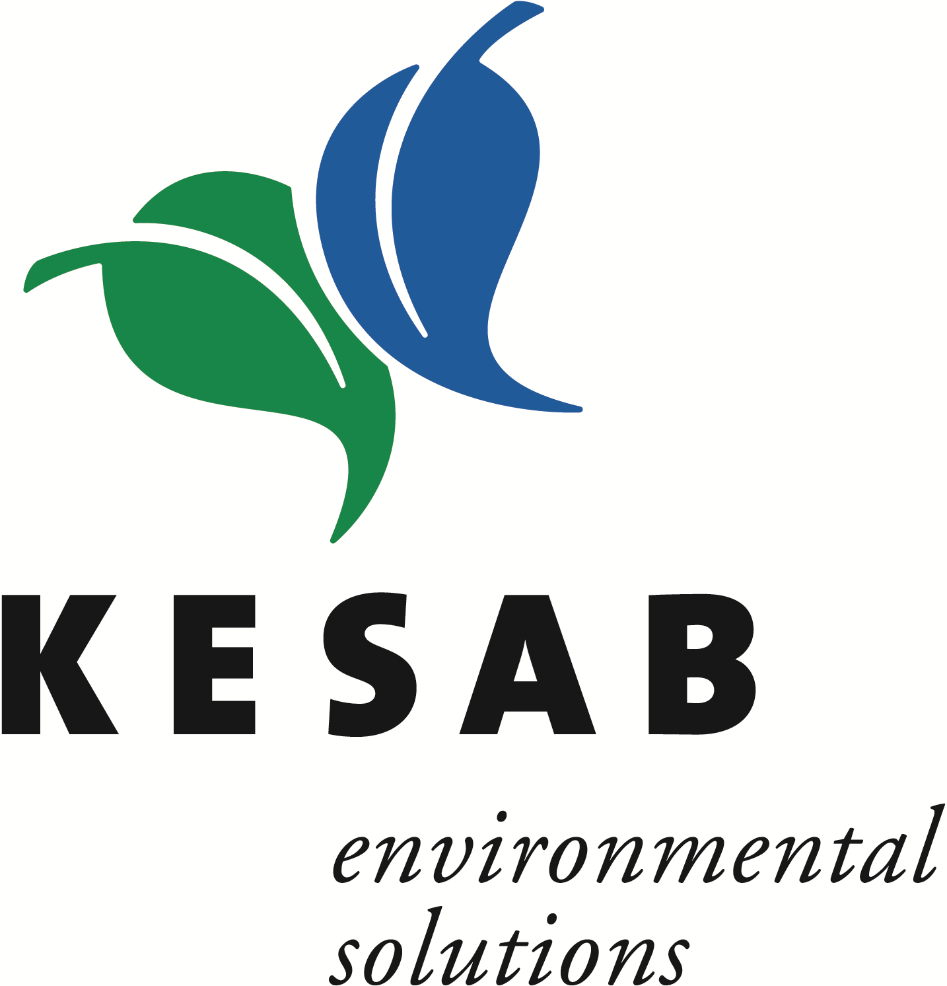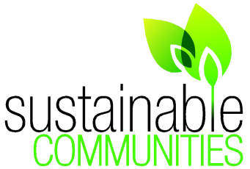
KESAB SUSTAINABLE COMMUNITIES
2023-24
SUBMISSION FORM

Thank you for your efforts and engagement with Sustainable Communities. We welcome your submission to South Australia’s Sustainable Communities Awards 2023-24 Program.
You can enter one or more initiatives that have been planned, maintained or initiated during January 2022-June 2023 in one or more categories. All initiatives are considered with weighted assessment and criteria is available on the KESAB Sustainable Communities webpage.
Please provide a description of around 400 words per initiative within this submission, to offer judges a clear picture of the initiative and its impacts.
Please complete all sections (1-4) of this submission form with as much detail as possible (within word limits).

Section 1
Town/Community name:
Name of organisation submitting entry:
Date of registration:
(If registered)
Media authorisation
I ………………………………...on behalf of …………………………………….... give permission to KESAB environmental solutions to use (free of any reimbursement) any photographs, images and stories presented as part of this submission. I understand that they may appear in publications, websites or presentations promoting the program.
If any children appear in the photographs, their permission or parent/guardian permission has been granted.
Signed ……………………………………………………………………………………. Date ……………………………………

Please upload clearly labelled photos/videos with your submission. (Labels include name & registration number)

Section 2
Please tick the categories you are entering:
Appearance, amenities & facilities |  | Community action & partnerships | Environmental sustainability & education
Health & wellbeing |  | Heritage & culture | Leadership & youth activities
Natural environment management | Resource recovery, waste management, litter prevention and enforcement

GENERAL INFORMATION
Town/Community name:
Council area/Local Government Agency:
Town/community population:
Number of volunteers involved in the initiative:
Total number of people involved in initiative:
(Including paid staff)
Number of hours collectively worked on the initiative:
General background of town/community: (please provide some background information about the community. I.e. main industries, demographics, any special features and other important contextual information).

When submitting initiatives, consider the following points:
- PROCESS – How was the initiative undertaken?
- MOTIVATION – Why was the initiative undertaken? What were the objectives?
- COMMUNITY PARTICIPATION – Who was involved? Has there been collaboration between participants?
- COMMUNITY AWARENESS AND EDUCATION – How has the local community been kept informed and what has the community learnt about the initiative or the objectives?
- OUTCOMES – What are the community and environmental benefits and overall outcomes?
- COST – What were the costs associated with the initiative? (Financial or other).
- FUNDING AND PARTNERS – How was the initiative funded; financially/ in-kind support?
- LESSONS LEARNT – Could anything be done differently? What were some of the surprises?
- ONGOING – Is there ongoing commitment to maintain or expand the initiative?

Section 3
Appearance, amenities and facilities
This category recognises the appearance of a town/community, as well as the amenities and tourist facilities.
Please provide the following information within the total category word limit of 400 words.
Initiative title:

Initiative description:

Initiative date/duration:

Initiative proponents:

Initiative outcomes:

Attachments (Yes/No & details-please attach as jpegs):

Community action and partnerships
This category recognises the partnerships formed in communities, between schools, community groups, business, industry and local government to protect, enhance and promote the community and its features.
Please provide the following information within the total category word limit of 400 words.
Initiative title:

Initiative description:

Initiative date/duration:

Initiative proponents:

Initiative outcomes:

Attachments (Yes/No & details-please attach as jpegs):

Environmental sustainability and education
This category recognises the sustainable use of resources and the creation of sustainable communities, specifically in relation to environmental education, at both school and community levels.
Please provide the following information within the total category word limit of 400 words.
Initiative title:

Initiative description:

Initiative date/duration:

Initiative proponents:

Initiative outcomes:

Attachments (Yes/No & details-please attach as jpegs):

Health and wellbeing
This category recognises initiatives that contribute to the health and wellbeing (i.e., physical, mental, spiritual, emotional) of the community, with linkages to the environment.
Please provide the following information within the total category word limit of 400 words.
Initiative title:

Initiative description:

Initiative date/duration:

Initiative proponents:

Initiative outcomes:

Attachments (Yes/No & details-please attach as jpegs):

Heritage and culture
This category recognises initiatives that preserve, celebrate and/or value Indigenous and non-Indigenous (including maritime, agricultural, industrial) heritage and culture.
Please provide the following information within the total category word limit of 400 words.
Initiative title:

Initiative description:

Initiative date/duration:

Initiative proponents:

Initiative outcomes:

Attachments (Yes/No & details-please attach as jpegs):

Leadership and youth activities
This category recognises the achievements by young individuals or groups in community participation and initiatives.
Please provide the following information within the total category word limit of 400 words.
Initiative title:

Initiative description:

Initiative date/duration:

Initiative proponents:

Initiative outcomes:

Attachments (Yes/No & details-please attach as jpegs):

Natural environment management
This category recognises the protection, conservation and enhancement of the natural environment, including but not limited to waterways, flora, fauna, corridors, roadsides and recreation areas.
Please provide the following information within the total category word limit of 400 words.
Initiative title:

Initiative description:

Initiative date/duration:

Initiative proponents:

Initiative outcomes:

Attachments (Yes/No & details-please attach as jpegs):

Resource recovery, waste management, litter prevention and enforcement
This category recognises achievements in reducing, reusing, and recycling resources/’waste’. It incorporates litter prevention and management (including enforcement), education/awareness raising and material management.
Please provide the following information within the total category word limit of 400 words.
Initiative title:

Initiative description:

Initiative date/duration:

Initiative proponents:

Initiative outcomes:

Attachments (Yes/No & details-please attach as jpegs):

Section 4
Supporting evidence
Documentation, images and/or media can support your initiative submission. Please provide this to show the ‘big picture’ impact of the initiative.
Please record and attach any supporting evidence here.
Supporting evidence name:
1.
2.
3.
4.
5.

Supporting evidence format (image/letter/video):
1.
2.
3.
4.
5.

Supporting evidence (inset here or detail how it has been submitted i.e. email/WeTransfer):

SUBMISSION

Please send your completed submission including all relevant attachments/supporting evidence to: communities@kesab.asn.au between 30th May and 30th September 2023.
If files are larger than 35MB, please send via WeTransfer or other relevant sharing platform so that all images and content can be assessed.
If you encounter any problems or would like assistance, please call Sarah on 08 8234 7255
Please check the KESAB Sustainable Communities webpage for information.
Judging and site visits will be undertaken from October 2023.
A South Australian Awards ceremony will be held in the first half of 2024.
If you require any assistance, please call Sarah at KESAB on (08) 8234 7255 or email communities@kesab.asn.au

Thank you & all the best.

